Nathan Hanuscin

Partner – Brian Lopez

CPE301 – SPRING 2018

Design Assignment Midterm 2

**DO NOT REMOVE THIS PAGE DURING SUBMISSION:**

The student understands that all required components should be submitted in complete for grading of this assignment.

|  |  |  |  |
| --- | --- | --- | --- |
| **NO** | **SUBMISSION ITEM** | **COMPLETED (Y/N)** | **MARKS**  **(/MAX)** |
| 1 | COMPONENTS LIST AND CONNECTION BLOCK DIAGRAM w/ PINS |  |  |
| 2. | INITIAL CODE OF TASK 1/A |  |  |
| 3. | INCREMENTAL / DIFFERENTIAL CODE OF TASK 2/B |  |  |
| 3. | INCREMENTAL / DIFFERENTIAL CODE OF TASK 3/C |  |  |
| 3. | INCREMENTAL / DIFFERENTIAL CODE OF TASK 4/D |  |  |
| 3. | INCREMENTAL / DIFFERENTIAL CODE OF TASK 5/E |  |  |
| 4. | SCHEMATICS |  |  |
| 5. | SCREENSHOTS OF EACH TASK OUTPUT |  |  |
| 5. | SCREENSHOT OF EACH DEMO |  |  |
| 6. | VIDEO LINKS OF EACH DEMO |  |  |
| 7. | GOOGLECODE LINK OF THE DA |  |  |
|  |  |  |  |
|  |  |  |  |

1. **COMPONENTS LIST AND CONNECTION BLOCK DIAGRAM w/ PINS**

2 nFR24L01/+

LM34 temperature sensor

2 FTDI breakout boards

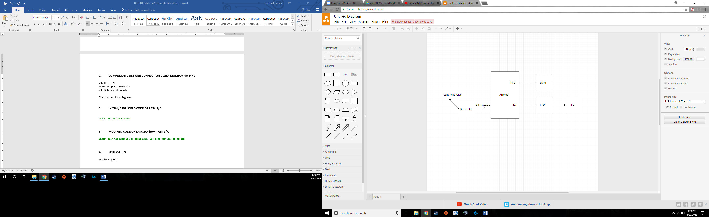Transmitter block diagram:

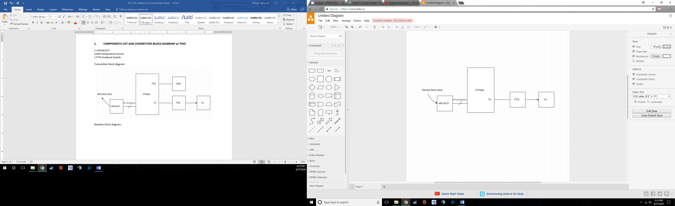Receiver block diagram:

1. **INITIAL/DEVELOPED CODE OF TASK 1/A**

Transmitter Given code:

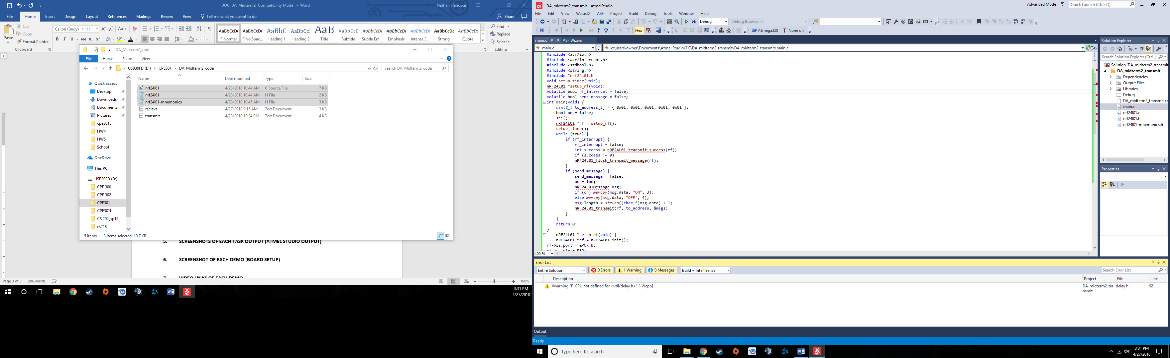

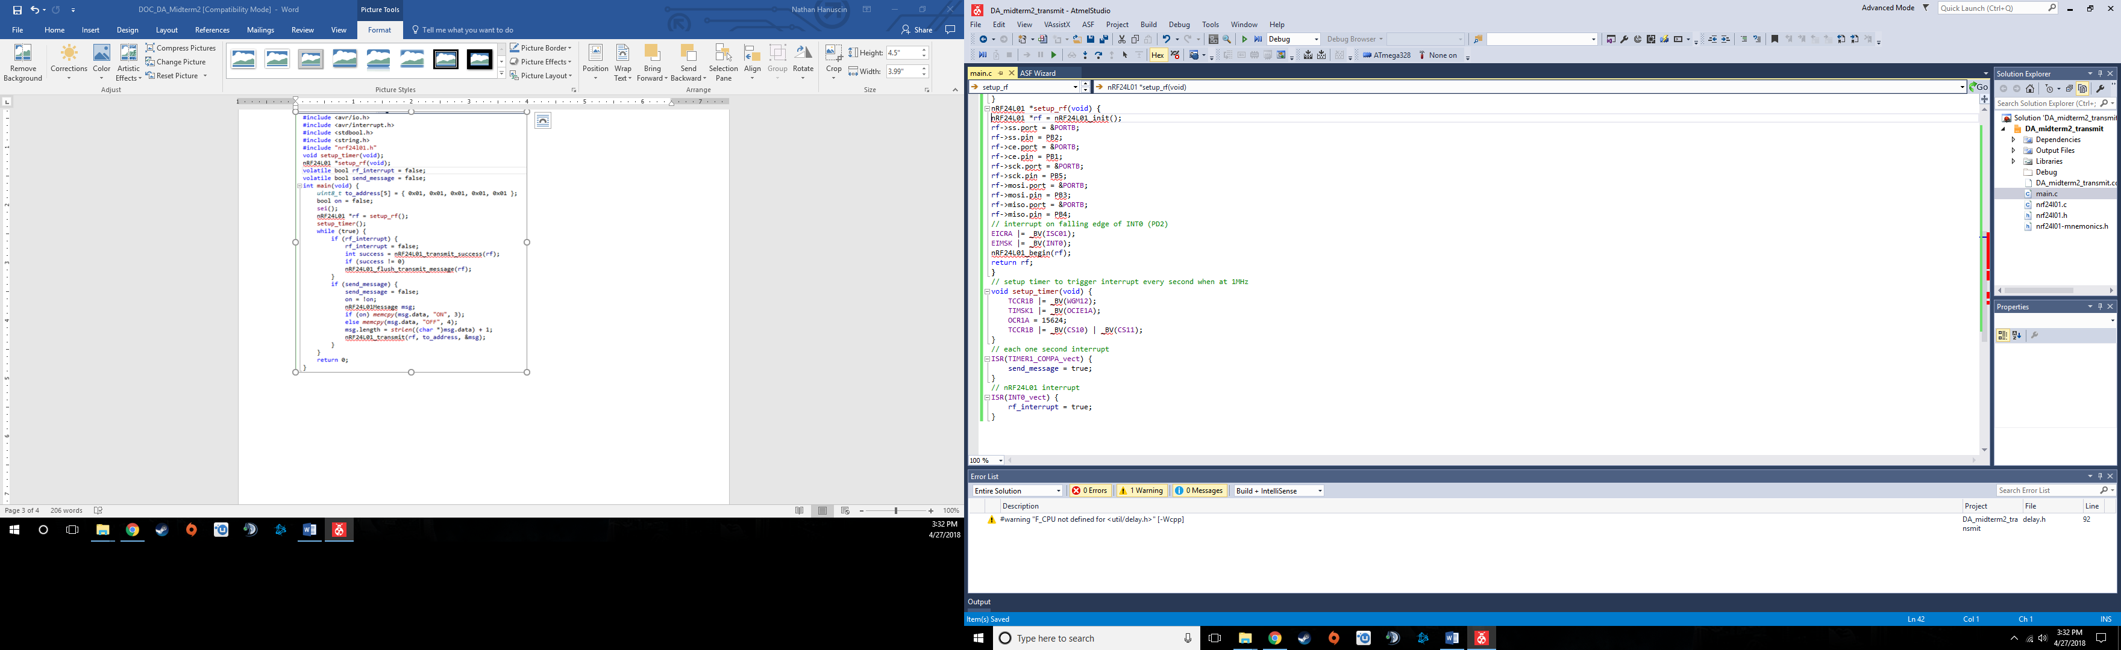

Receiver given code:

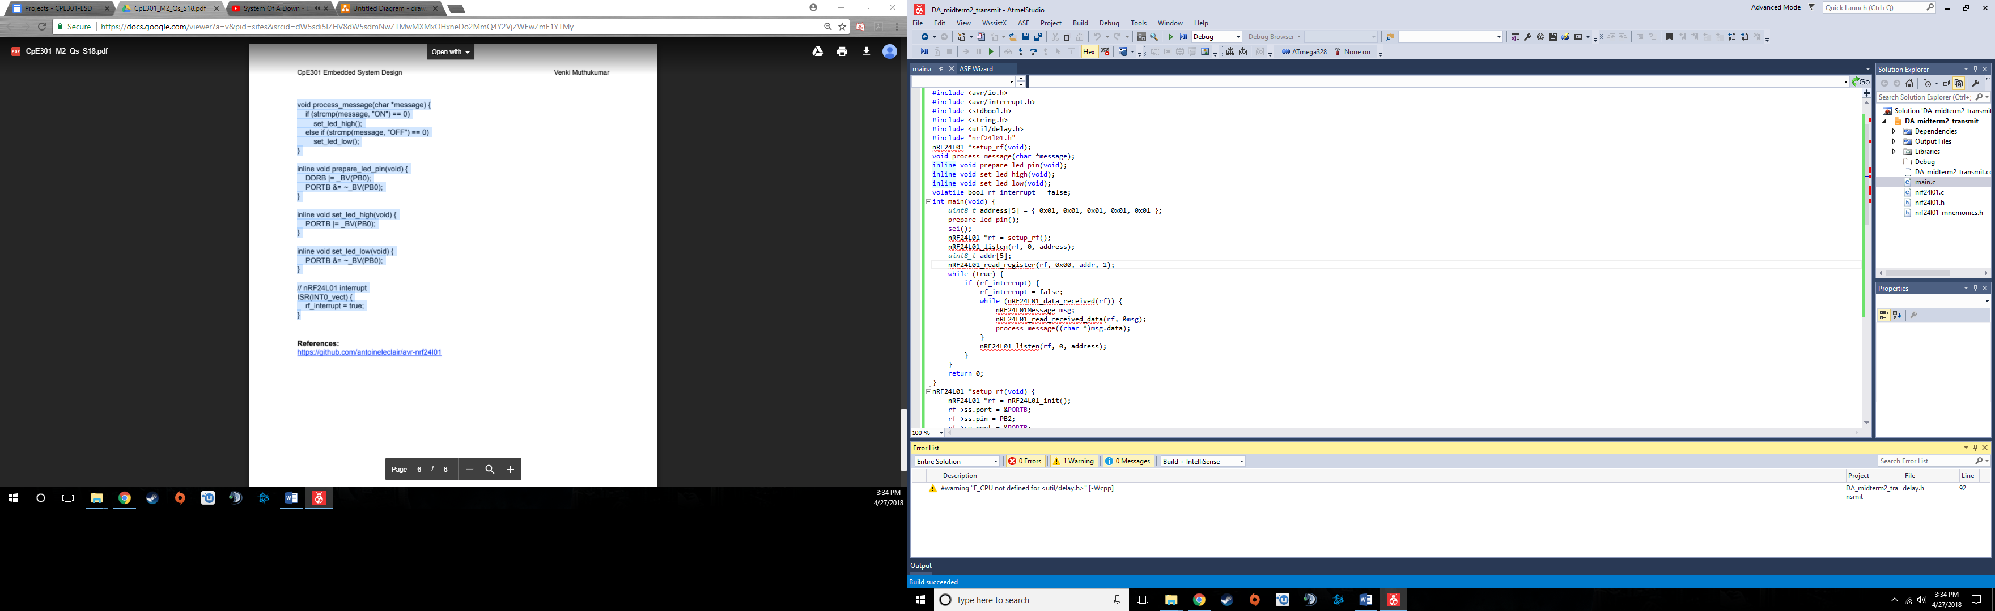

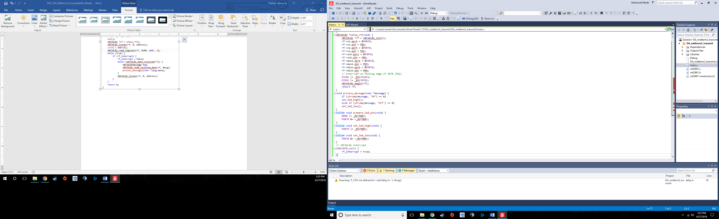

1. **MODIFIED CODE OF TASK 2/A from TASK 1/A**

Transmitter modified code:

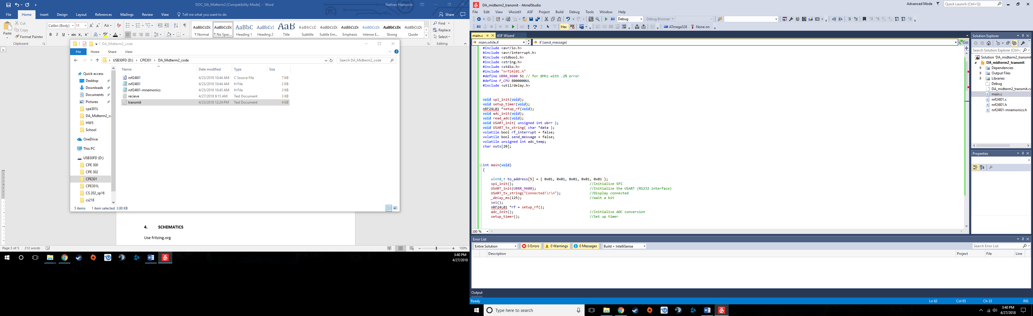

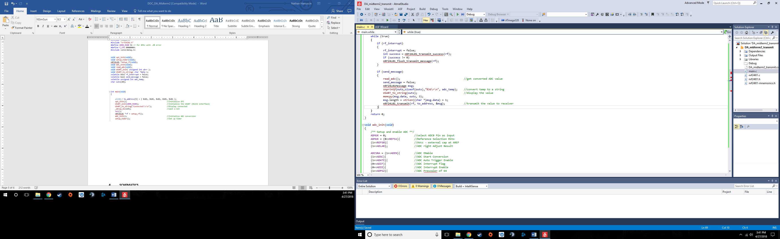

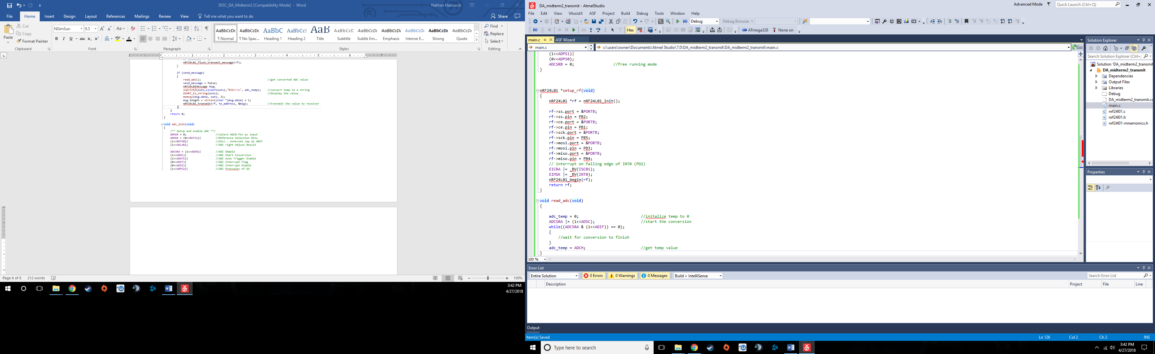

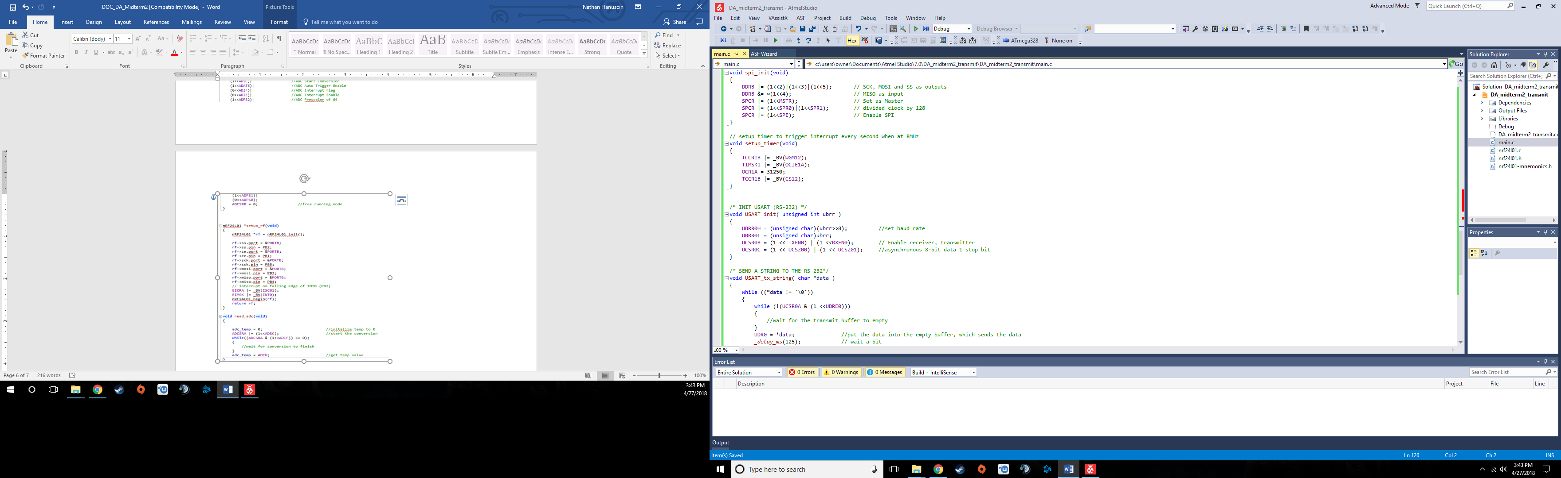

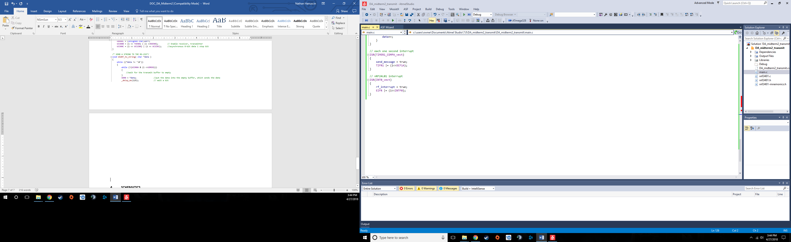

Receiver modified code:

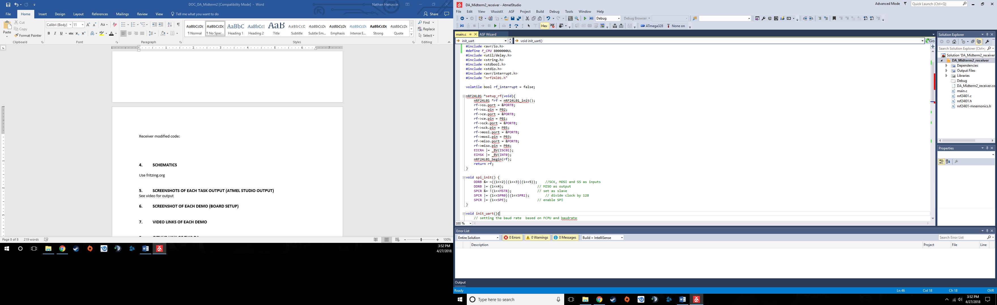

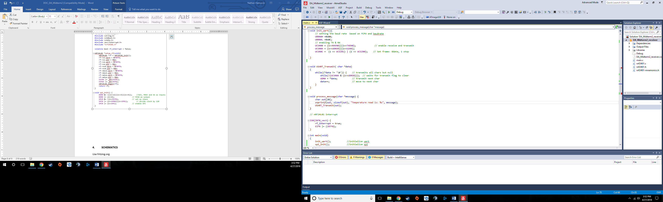

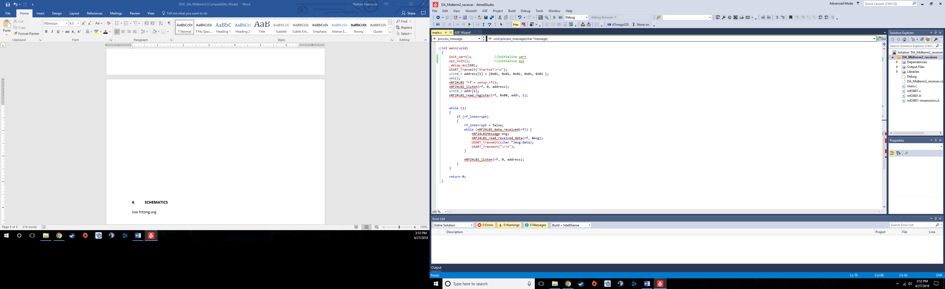

1. **SCHEMATICS**

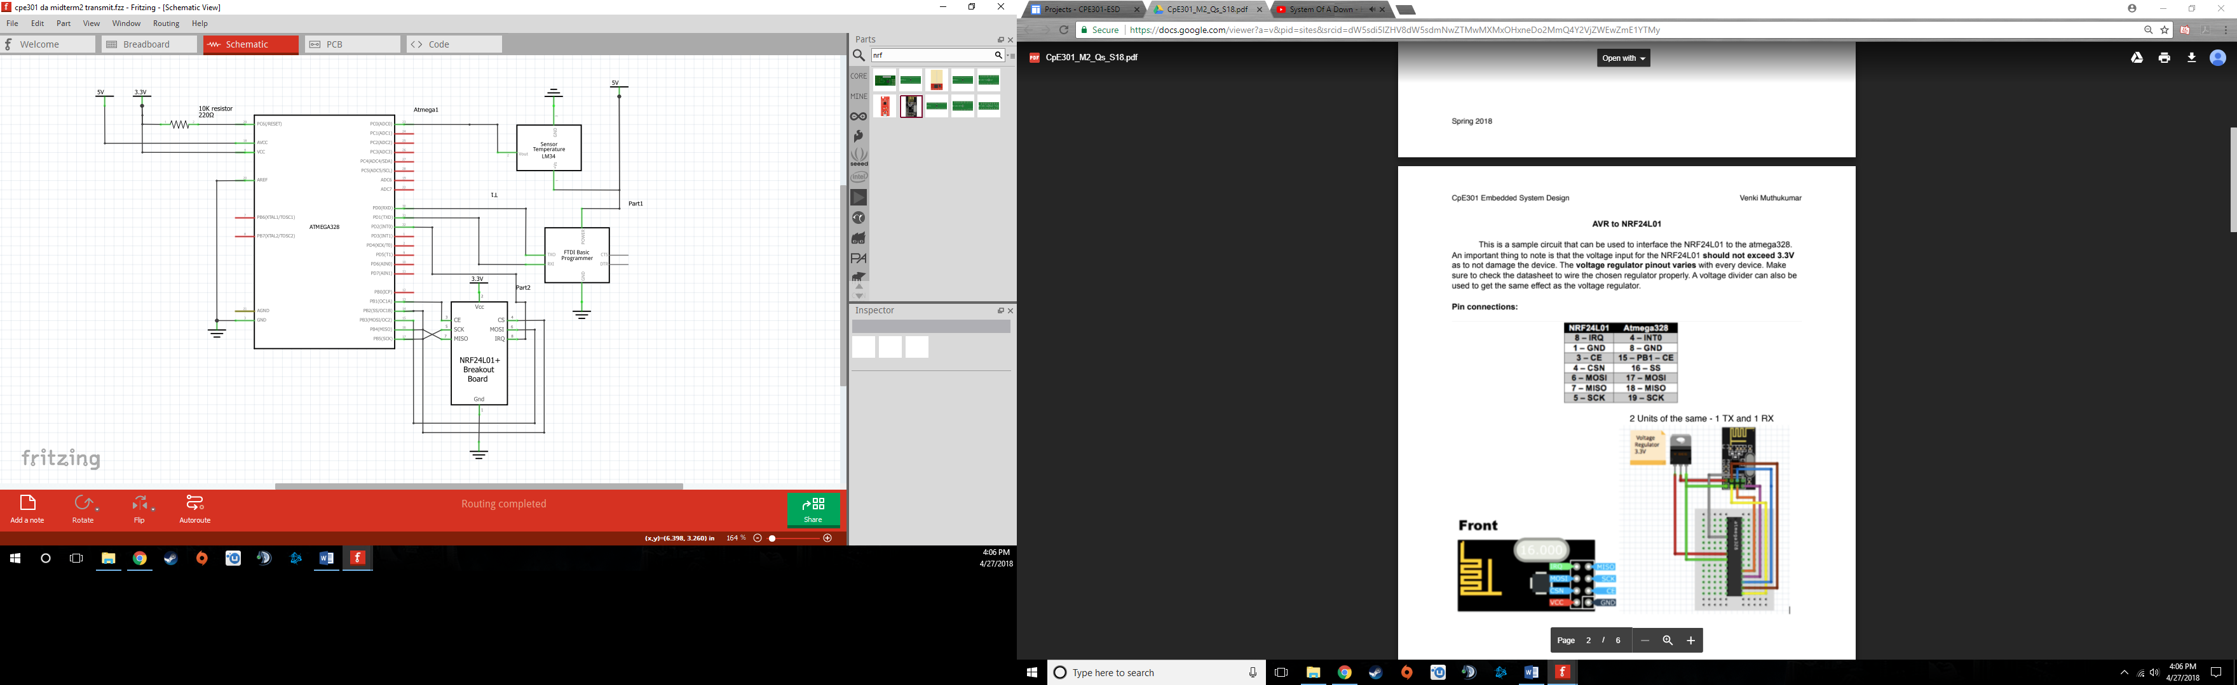Transmitter Schematic:

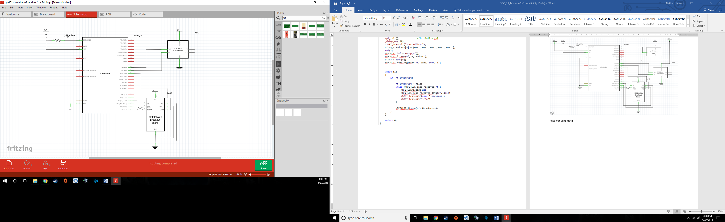Receiver Schematic:

1. **SCREENSHOTS OF EACH TASK OUTPUT (ATMEL STUDIO OUTPUT)**

See video for output

1. **SCREENSHOT OF EACH DEMO (BOARD SETUP)**

Transmitter:

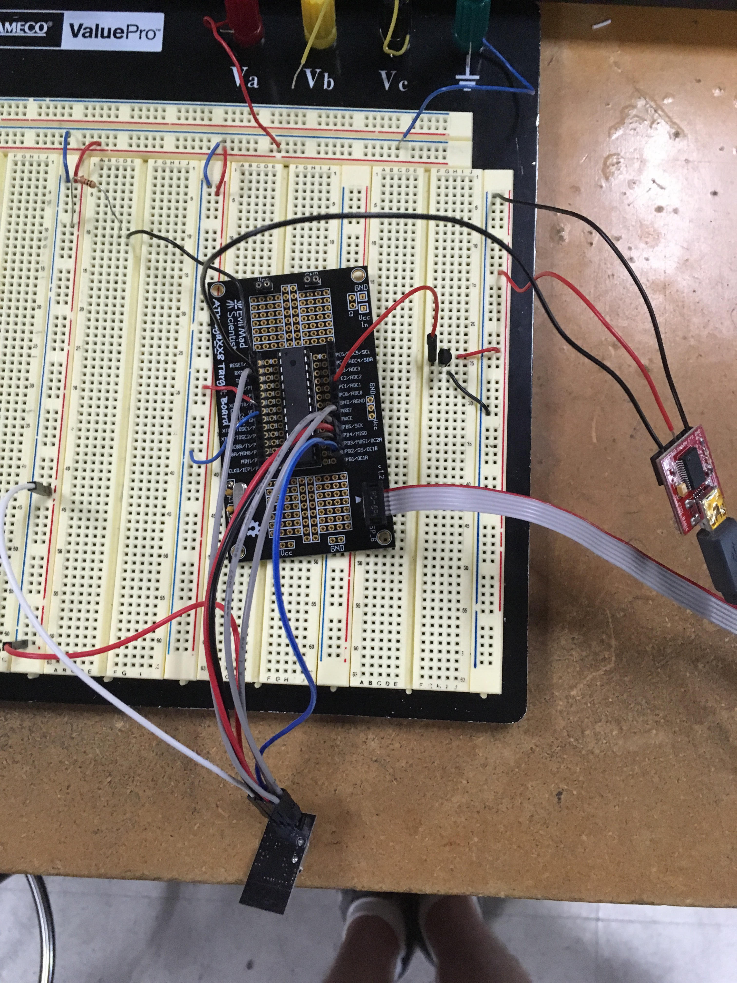

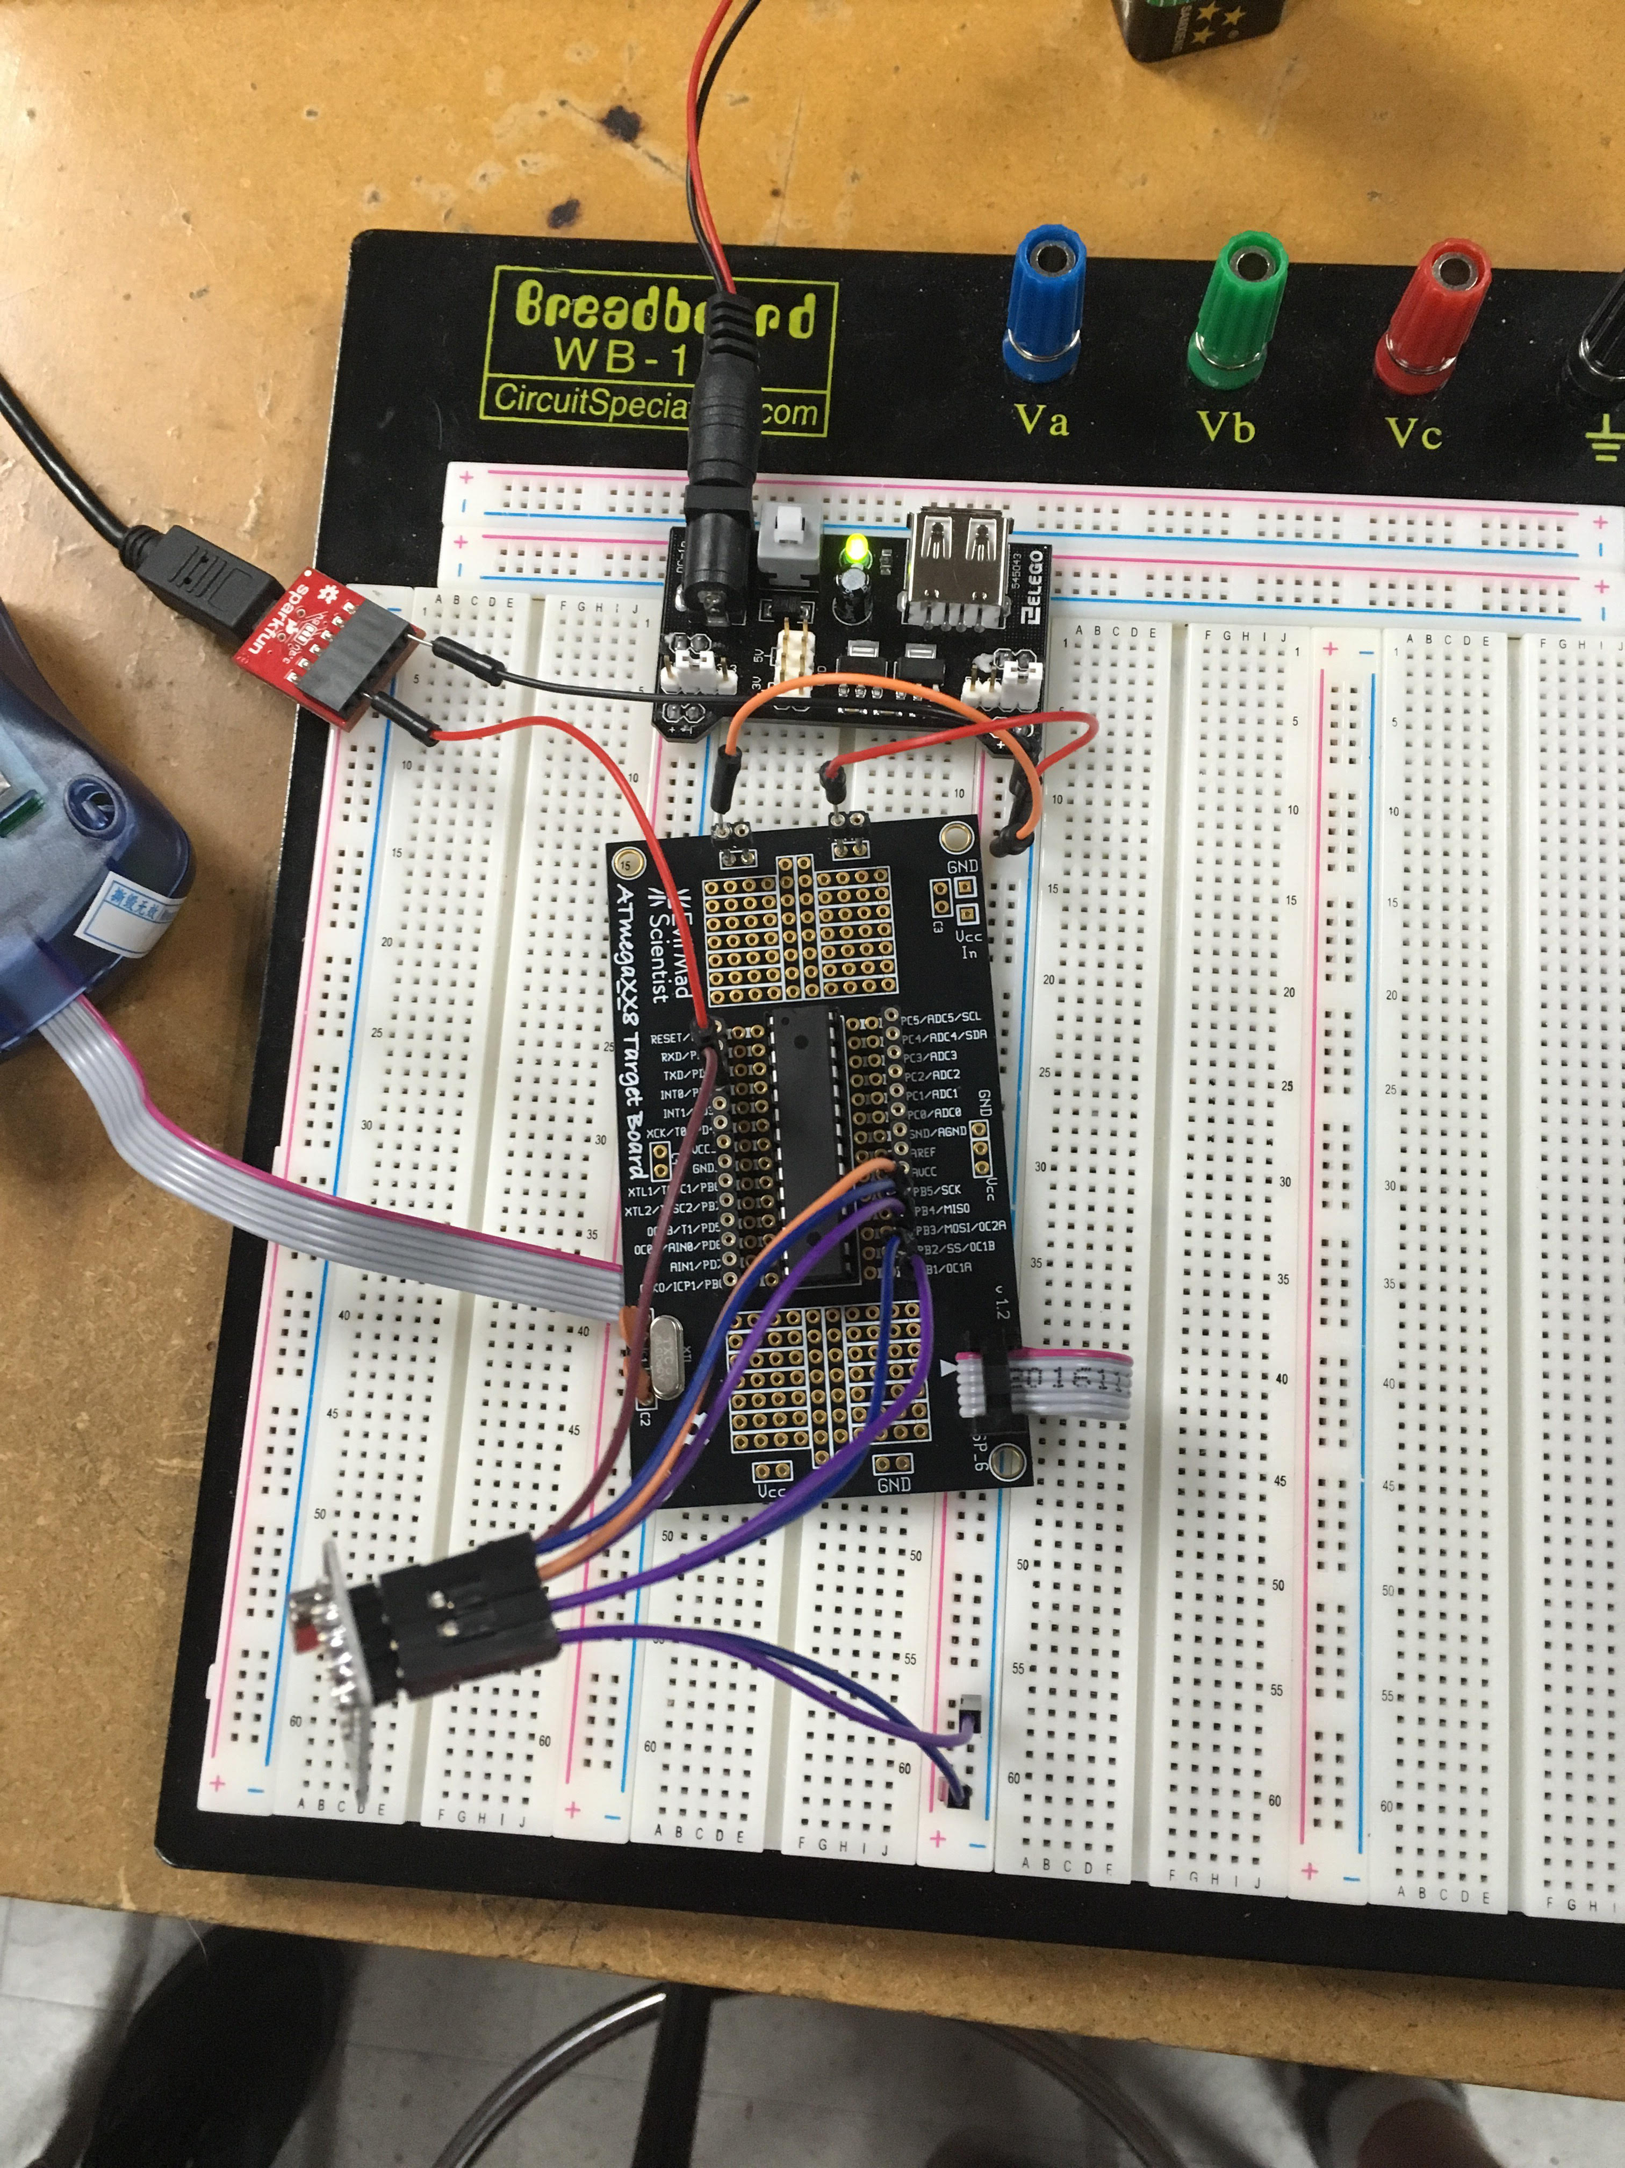Receiver:

1. **VIDEO LINKS OF EACH DEMO**

Video - https://www.youtube.com/watch?v=LW3HZ5QPJ_w

Playlist - https://www.youtube.com/channel/UCX_dEuWexNMLRw5YqdTRQTg/playlists

1. **GITHUB LINK OF THIS DA**

https://github.com/nhanuscin/submit/tree/master/DA_Midterm2

**Student Academic Misconduct Policy**

<http://studentconduct.unlv.edu/misconduct/policy.html>

“This assignment submission is my own, original work”.

Nathan Hanuscin

Partner – Brain Lopez